APPROVED WEAR SYSTEM

Character + Backpack
Reference & Continuity Guide
How to preserve the approved Terra Nexus character, glacier-blue jacket, rear hood compass, rust-orange backpack, and the way those assets fit together in future scenes.
Status: approved companion guide
Use this guide alongside the Character Reference & Continuity Guide v2.0 and the approved backpack product turnaround. Where older story images conflict with the approved studio references, the studio references in this guide take priority.

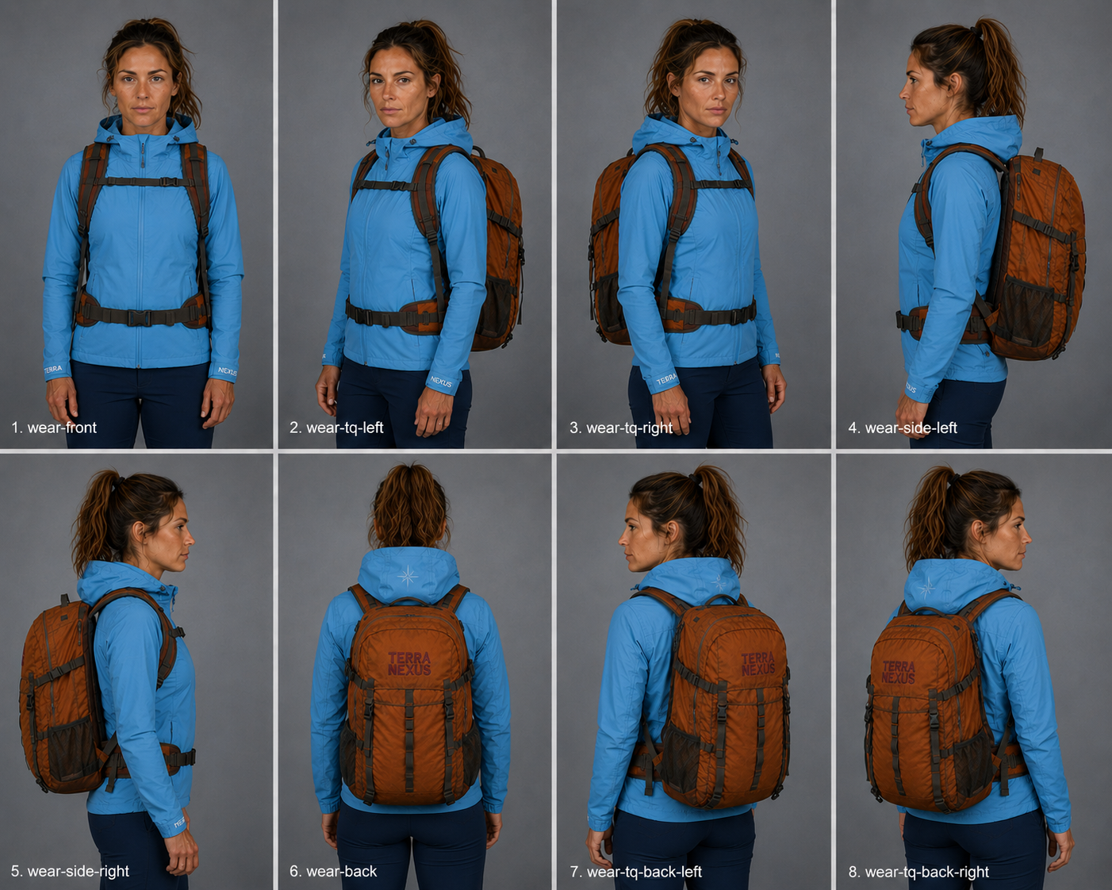
Primary worn-system reference: approved character + approved pack + approved hood compass.
Terra Nexus • controlled reference • one character / one jacket / one pack

1. Reference hierarchy and conflict rules
The character and backpack should be treated as a controlled multi-asset system. Future generation is safest when each approved image is assigned a specific job instead of asking one image to govern everything.
Reference | What it controls | Conflict rule
1 — Worn contact sheet | Fit, scale, strap path, pack height, body/pack relationship, occlusion, and how rear hood branding behaves around the pack. | Highest authority for how the assets sit together.
2 — Character reference set | Exact identity, face, hair, body proportions, jacket cut, cuff branding, and the subtle rear hood star/compass. | Wins for character identity and garment details.
3 — Pack front + product turnaround | Pack geometry, rust color, hardware, mesh pockets, strap construction, wear/scuffs, and centered embroidered wordmark. | Wins for backpack construction and pack branding.
4 — Scene continuity frame | Camera, terrain, props, weather, time of day, and story continuity. | Controls scene only; it must not redefine the character, jacket, or pack.

Non-negotiable conflict rule
- Face or hair conflict → the approved character references win.
- Jacket construction or hood-compass conflict → the latest character/worn references win.
- Pack size, hardware or wordmark conflict → the approved pack front/turnaround wins.
- How the pack sits on her body → the worn contact sheet wins.
- Older outdoor story images are composition references only if they disagree with the approved studio assets.
Important nomenclature
The pack’s “front” is its outward-facing branded face. The pack’s “back” is the harness side that touches the wearer. Therefore, a rear view of the character normally shows the PACK FRONT, not the pack back.

2. Approved worn-angle map
Use the closest approved worn angle whenever the backpack is on the character. Do not use a front-facing character reference to invent rear strap geometry, or a pack-only image to invent how the hood and ponytail interact with the harness.

Approved worn contact sheet — use the closest angle as the fit/occlusion anchor.

Angle-use matrix
Shot | Best use | Continuity job | Brand visibility
1. wear-front | Front / near-front scene | Shoulder straps, sternum strap, hip belt; pack body mostly hidden. | No hood star; pack wordmark not visible.
2. wear-tq-left | Three-quarter left | Left-side carry geometry and body/pack depth. | Front-facing jacket rules; pack wordmark generally hidden.
3. wear-tq-right | Three-quarter right | Right-side carry geometry and body/pack depth. | Front-facing jacket rules; pack wordmark generally hidden.
4. wear-side-left | Full left profile | Pack depth, shoulder strap curve, hip belt placement. | Side surfaces unbranded.
5. wear-side-right | Full right profile | Pack depth, shoulder strap curve, hip belt placement. | Side surfaces unbranded.
6. wear-back | Straight rear | Primary relationship reference for pack scale and hood position. | Centered pack wordmark visible; subtle hood star visible.
7. wear-tq-back-left | Rear three-quarter left | Perspective/occlusion reference for pack + hood. | Wordmark foreshortens naturally; star partially visible.
8. wear-tq-back-right | Rear three-quarter right | Perspective/occlusion reference for pack + hood. | Wordmark foreshortens naturally; star partially visible.

3. Character and jacket lock
The backpack does not create a new version of the character. Her identity, hairstyle, expression range and jacket remain governed by the approved character system.
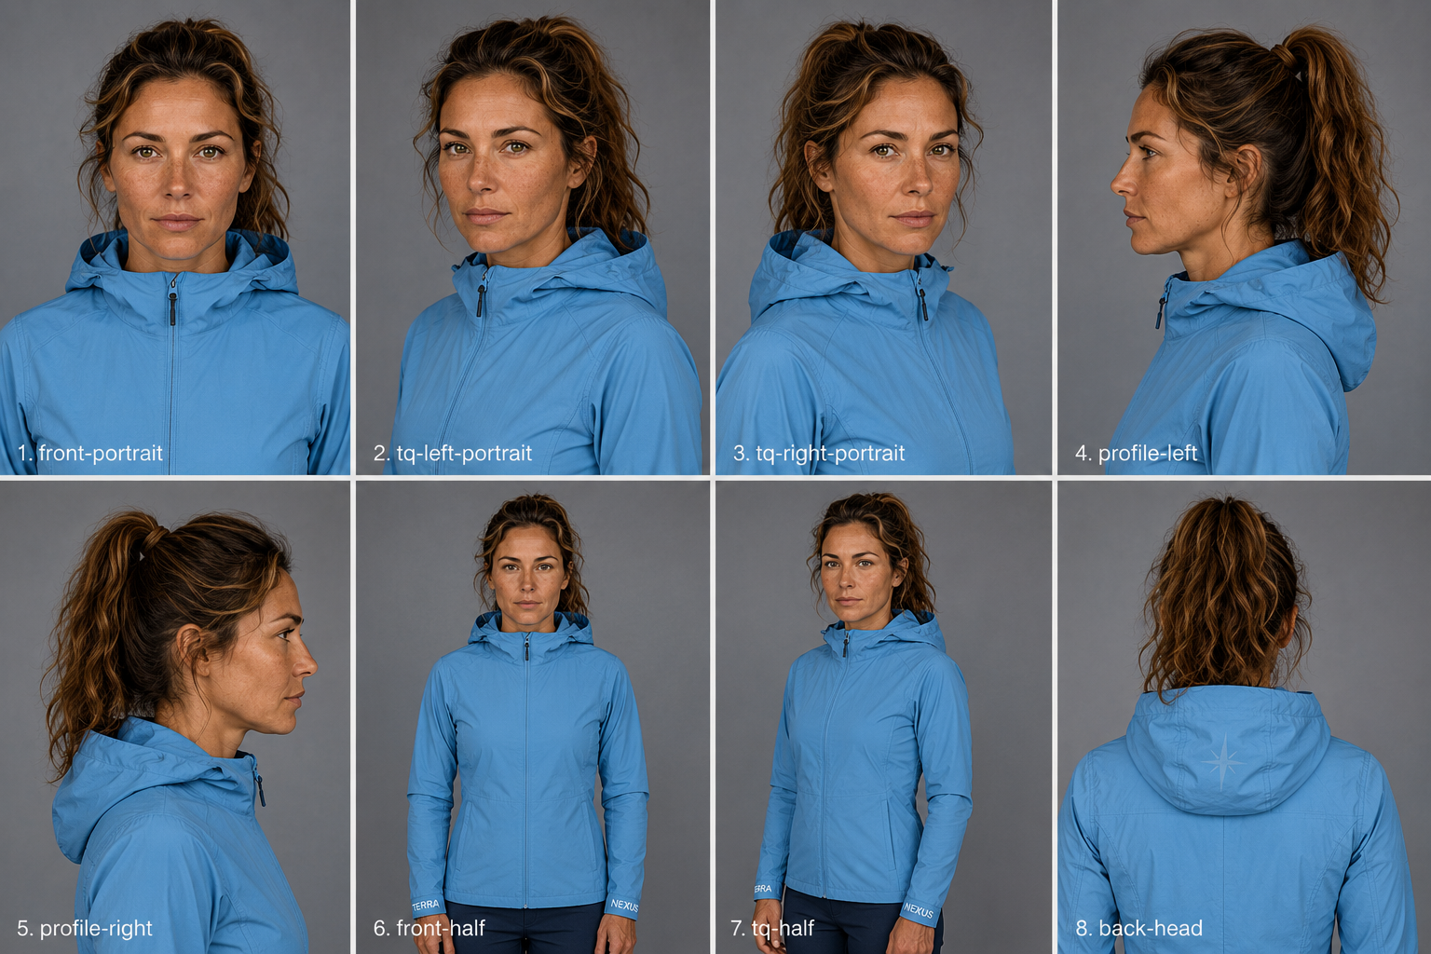
Supporting character reference: identity, jacket geometry, and rear hood treatment.

Identity lock
- Same woman in every frame — not a similar-looking woman.
- Late-thirties, athletic build; oval face, defined jaw, straight nose, green-hazel eyes, strong straight mid-brown brows.
- Warm, sun-weathered natural skin with visible freckles across the nose and upper cheeks; no beautification or de-aging.
- Mid-brown hair with caramel highlights, always in the established mid-height ponytail with loose strands at the temples and crown.
- Ponytail remains free above the pack. Do not tuck it into the hood, shoulder straps, or pack.

Jacket lock
- Glacier blue #5A90BE; slim close-fitting single-layer shell with raglan sleeves and princess seams.
- Full-length front zip closed; hood always down and bunched behind the neck.
- Cuffs lie flat and shaped — not gathered or elasticated.
- Left cuff reads TERRA; right cuff reads NEXUS, in white block capitals. No other jacket lettering.
- No shoulder, upper-arm, chest patch, badge, wordmark or star.

Rear hood compass and brand separation
- One subtle, washed-out Terra Nexus star/compass on the rear hood only.
- It is pale and low-contrast, integrated into the blue fabric rather than reading like a bright printed logo.
- It is centered on the rear hood panel and follows the hood’s folds and perspective.
- In rear three-quarter views, allow normal partial visibility. Never move, enlarge or duplicate the mark just to keep it readable.
Brand separation rule
The hood owns the star/compass. The backpack owns the TERRA / NEXUS embroidered wordmark. Do not place the compass on the pack, and do not place the full wordmark on the jacket hood.

4. Backpack lock: exact product, exact centered wordmark
Treat the pack as a product identity anchor. Its silhouette, volume, construction, webbing, mesh pockets, hardware, wear pattern and wordmark must remain stable across scenes.
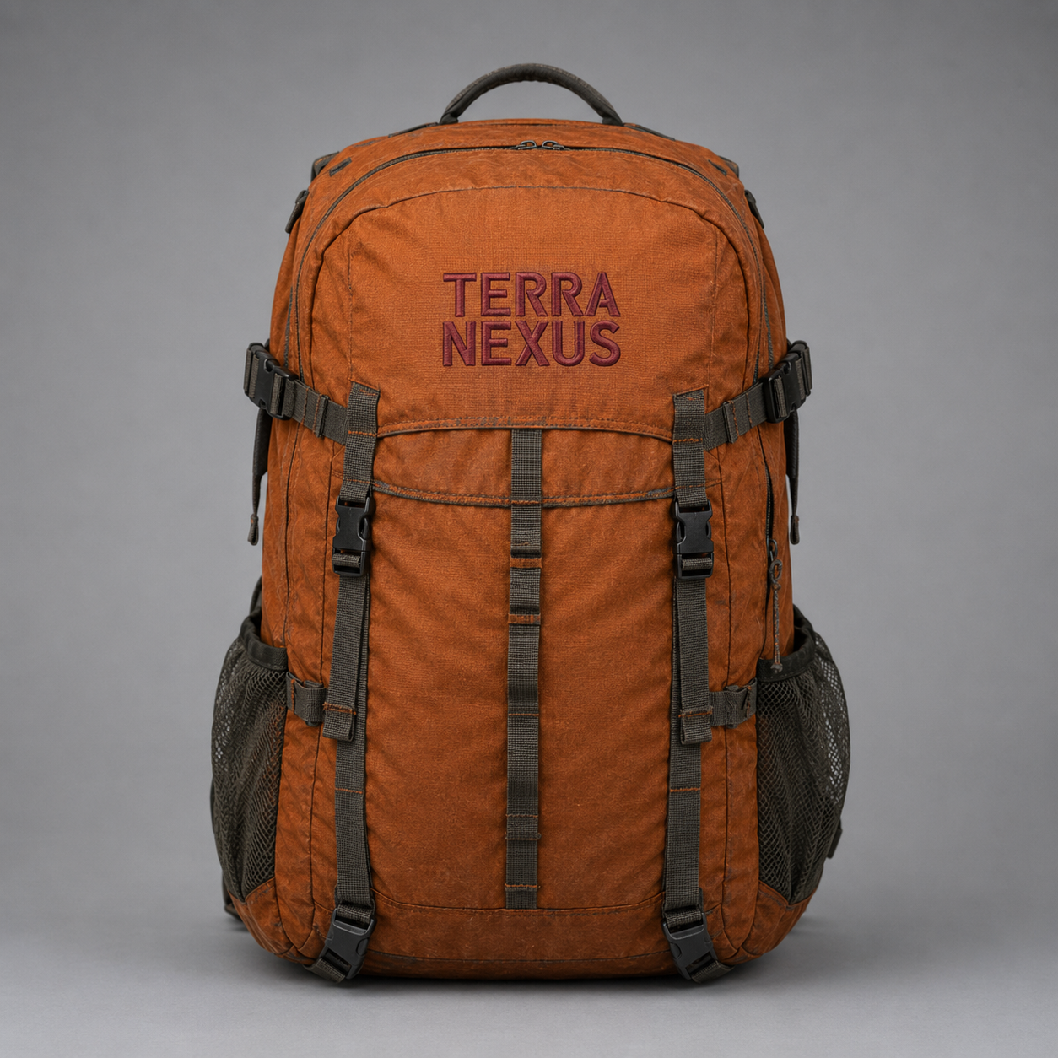 | Approved product characteristics  - Technical hiking daypack, approximately 30 L.  - Rust orange: burnt, earthy and slightly desaturated; matte ripstop nylon with low sheen.  - Used, not new: faint trail dust, small scuffs and softened corners.  - Rounded top lid over the main opening; large front pocket panel; two vertical charcoal front compression straps with black side-release buckles.  - Dual side compression straps; grey-olive stretch mesh pockets; charcoal zip tape and cord pulls.  - Padded charcoal shoulder straps, sternum strap, dark hip belt and charcoal grab handle; black hardware throughout.

Centered wordmark — latest approved placement
- The TERRA / NEXUS block is DEAD CENTER horizontally on the visible lid/front upper panel. Do not shift it left or right.
- TERRA is above NEXUS; both lines form a squared block with matching visual width and aligned edges.
- Embroidery is faded deep oxblood #6A1B32, approximately 85 mm wide, reading primarily as raised stitch texture rather than high-contrast color.
- Raised satin stitch sits directly in the orange fabric: no patch, border, rectangle, badge or backing panel.
- The wordmark exists in exactly one place on the pack. Every other surface is unbranded.
- Do not add a star, mountain, icon, extra text, manufacturer mark or duplicate TERRA NEXUS on any strap, side pocket, harness, buckle, pull or belt.

Full product turnaround
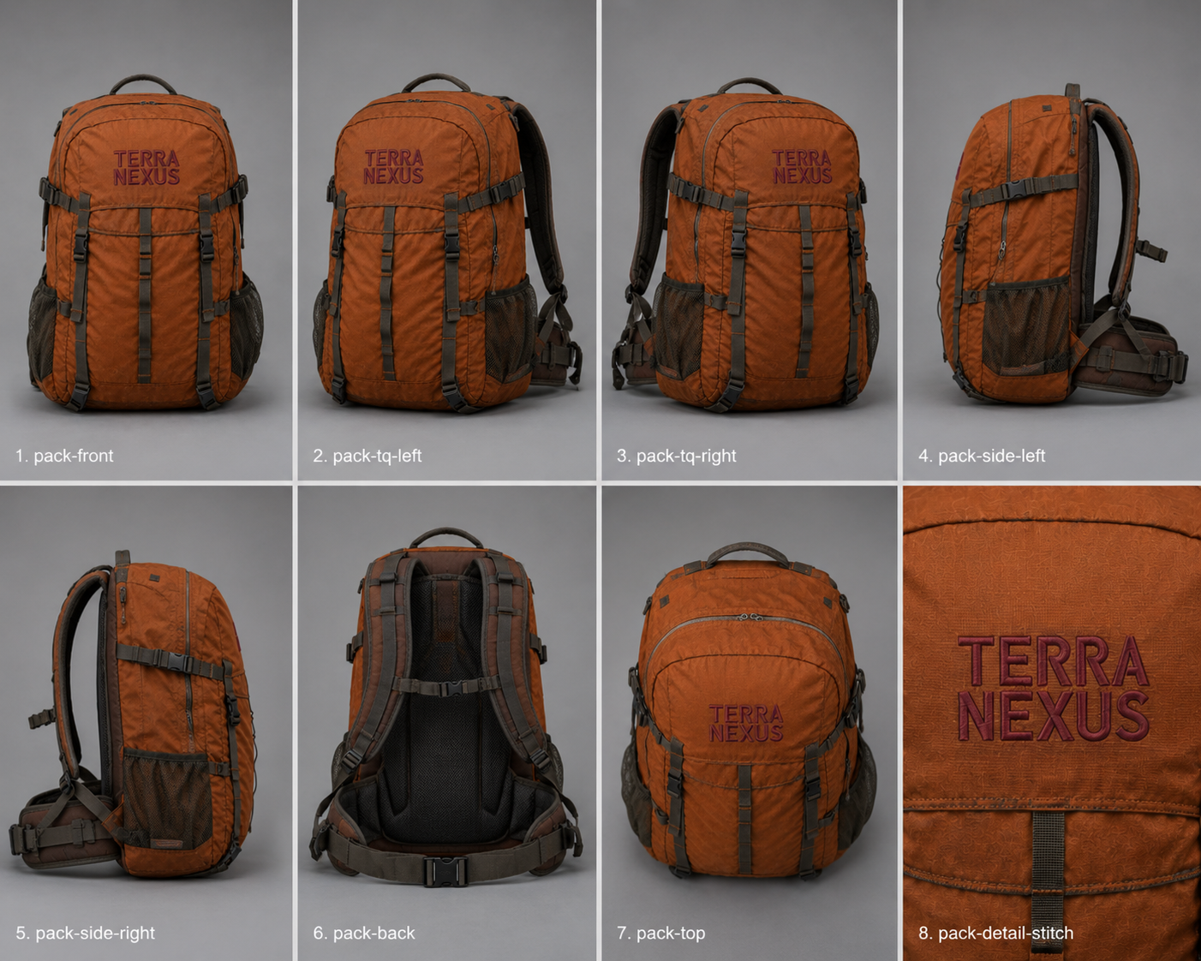
Approved pack turnaround — use the matching angle to preserve geometry, hardware and unbranded surfaces.

5. How the pack must fit the character
The relationship between the pack and the body is a continuity feature. Even when a future scene changes pose or terrain, the pack should still feel like the same 30 L object adjusted to the same wearer.
Continuity feature | Approved behavior
Scale | Maintain the same apparent 30 L volume. Do not let the pack grow into an expedition pack or shrink into a commuter/day sling.
Centerline | Pack stays centered along the spine. In straight rear views, the wordmark block and pack body align with the wearer’s centerline.
Vertical position | Top of pack sits close behind the shoulder/hood region; bottom terminates around the lower back/upper hip area rather than hanging low.
Shoulder straps | Straps emerge over the shoulders, conform to the jacket and show realistic load tension. No floating gaps or impossible intersections.
Sternum strap | Runs horizontally across the upper chest when visible, joining the shoulder straps without distorting the jacket zipper.
Hip belt | Sits at the established waist/upper-hip height and wraps naturally around the torso. Keep buckle scale stable.
Hood relationship | Hood remains down above the pack. Rear hood star may be partially obscured by folds, ponytail or pack handle; do not relocate it.
Hair relationship | Ponytail stays outside the harness and above the pack, with loose strands behaving naturally. Never thread hair through straps.
Contact realism | Show small fabric compression where straps load the jacket and where the pack rests against the back. The pack should not float.
Perspective | Branding, webbing and pack width foreshorten naturally with angle. Do not rotate the logo independently of the product surface.
Occlusion is allowed
A correct reference may hide part of a logo, strap or hood mark. Preserve physical truth. Never invent a second logo, move a mark, or distort the pack merely to make branding visible.

6. Reference selection for future scenes
Choose references by camera angle and by what the new image needs to preserve. Use the minimum set that fully controls identity, product geometry and worn fit.
Scene type | Attach these references | Priority
Front / front three-quarter | Front identity anchor + wear-front or matching wear-TQ + matching pack angle if the pack body is visible. | Face and strap fit are more important than showing the pack wordmark.
Full side | Matching character side/profile + matching wear-side + matching pack-side. | Keep side surfaces unbranded; preserve pack depth.
Straight rear | wear-back + character back-head/hood reference + pack-front. | Critical combination: pack FRONT faces camera; hood star above it.
Rear three-quarter | Matching wear-TQ-back + pack-TQ-front + character hood reference. | Allow natural perspective and partial star visibility.
Action / hiking | Closest wear angle + closest pack angle + front identity anchor + previous approved scene if continuity matters. | Change pose and environment, not the assets.
Pack removed / set down | Pack-only turnaround angle; character reference only if she remains in frame. | Once off-body, pack geometry is governed by pack-only references.

Generation workflow
- Pick the final camera angle and framing before generating.
- Select the closest worn reference angle.
- Add the front character identity anchor whenever her face is visible.
- Add the closest pack-only angle whenever pack construction is prominent.
- If the scene is part of a sequence, add the immediately preceding approved story frame for environment/camera continuity.
- State explicitly what is allowed to change: pose, terrain, weather, action, crop, or lighting.
- State explicitly what is locked: woman, hair, jacket, hood star, pack, centered wordmark, strap fit.
- Generate one shot/angle at a time and approve it before using it as continuity context for a later frame.
Do not chain from an off-model frame
If a generated image drifts, regenerate from the approved anchors. Do not use a slightly wrong face, pack, wordmark or hood mark as the reference for the next image; drift compounds quickly.

7. Copy-ready master prompt for the character wearing the pack
Use the following structure as the default starting prompt. Replace only the bracketed scene fields and angle references.
REFERENCE PRIORITY
1) The attached front portrait is the locked identity anchor. This is the woman. Match this exact face; a similar-looking woman is a failed result.
2) The attached [WEAR SHOT ID] is the primary body / backpack-fit / occlusion reference for this frame.
3) The attached [PACK SHOT ID] controls backpack geometry, hardware, color, wear and the centered embroidered wordmark.
4) [OPTIONAL] The attached previous approved story frame controls environment, camera and story continuity only.

CREATE
Generate one image of the same Terra Nexus woman wearing the same Terra Nexus backpack in [SCENE / ACTION / POSE]. Camera: [ANGLE / FRAMING / LENS FEEL]. Environment and lighting: [DESCRIPTION].

CHARACTER + JACKET LOCK
Preserve her exact face, natural freckles, green-hazel eyes, mid-brown ponytail with caramel highlights and loose strands. Keep the glacier-blue #5A90BE slim hooded shell with raglan sleeves, princess seams, closed front zip and shaped cuffs. Hood down. TERRA on the left cuff and NEXUS on the right cuff in white block capitals. No shoulder, chest or upper-arm branding.

HOOD BRAND LOCK
On the rear hood only, preserve one subtle washed-out Terra Nexus star/compass. It must remain pale, low-contrast and integrated into the hood fabric. Allow normal folds and partial occlusion; never duplicate or relocate it.

BACKPACK LOCK
Use the exact same approximately 30 L rust-orange technical pack: matte worn ripstop, charcoal webbing, black hardware, grey-olive mesh side pockets, shoulder straps, sternum strap and hip belt. Preserve the same scale and fit on her body.
The only backpack branding is the TERRA / NEXUS raised satin-stitch wordmark on the outward lid/front upper panel. TERRA above NEXUS, squared block, DEAD CENTER horizontally, faded oxblood #6A1B32. No patch or backing panel. No branding anywhere else on the pack.

RELATIONSHIP LOCK
Pack centered on the spine; top close behind the shoulders/hood; bottom around the lower back/upper hip. Straps conform to the jacket with realistic load tension. Ponytail remains above and outside the harness. Do not make the pack float, sag, resize, or intersect the body.

DO NOT CHANGE
Do not redesign the woman, change her age or hairstyle, change jacket cut/color, move or strengthen the hood compass, alter pack capacity or construction, shift the pack wordmark, add extra branding, add props unless requested, add people, add text overlay, add watermark, or create a different backpack.

QUALITY GATE
The result must read as another photograph of the exact same woman, wearing the exact same jacket and exact same backpack with the same fit. If identity, backpack geometry, wordmark placement, cuff branding or hood compass drifts, regenerate rather than approximate.

8. Approval checklist and hard failure modes
A frame is not approved because it is attractive. It is approved only when the identity, garment, pack and their relationship all remain inside the locked system.
QC item | Pass | Hard fail
Identity | Exact same woman; face proportions, freckles, age and natural texture read correctly. | Different/similar woman; de-aged or beautified face.
Hair | Mid-height ponytail with established loose strands; above/outside harness. | Loose hair, braid, tucked hood, hair trapped through straps.
Jacket | Glacier blue; slim; correct seams; hood down. | Boxy shell, wrong blue, hood up, altered seams.
Cuffs | TERRA left / NEXUS right when visible. | Reversed, duplicated, missing when clearly visible, or extra garment text.
Hood compass | One pale washed-out star on rear hood only. | Bright logo, multiple stars, full wordmark on hood, star moved to pack.
Pack identity | Same rust 30 L pack, same hardware, mesh, wear and construction. | Different pack family, altered size, invented pockets/hardware.
Pack wordmark | TERRA over NEXUS, squared block, dead-center, oxblood raised stitch. | Shifted left/right, side-by-side text, patch/badge, wrong color or duplicate.
Brand count | One pack wordmark + one hood star + cuff words only. | Any extra logo, mountain, star, wordmark, patch or manufacturer mark.
Fit | Pack centered; realistic strap tension and hip-belt placement. | Floating pack, sagging low, oversized, straps clipping through body.
Angle | Reference angle and left/right orientation physically consistent. | Mirrored pack details or mismatched left/right geometry.
Scene | Lighting and environment may change while assets remain stable. | Outdoor lighting used as excuse to recolor or redesign the assets.

Regenerate rather than repair when
- the face is off-model;
- the backpack silhouette or hardware has changed;
- the centered wordmark is wrong;
- the hood star is missing in a clear rear view, too strong, or placed elsewhere;
- branding is duplicated;
- the pack sits at a different scale/height from the approved worn reference.

9. Canonical assets and version control
Keep approved references immutable. Create new versions only after review, and never silently replace the master assets used by an active story sequence.
Suggested canonical name | Asset | Use
TN_CHAR_contact_v2.png | Approved character angle set | Identity, jacket and hood-star master
TN_PACK_front_master_v1.png | Approved centered pack front | Primary pack branding and front geometry
TN_PACK_turnaround_v1.png | Approved 8-angle pack sheet | Pack construction / side / harness / detail
TN_CHAR_PACK_wear_contact_v1.png | Approved 8-angle worn sheet | Primary fit, scale and occlusion reference
TN_CHAR_Reference_Continuity_Guide_v2.docx | Character guide | Character-only continuity
TN_CHAR_PACK_Reference_Continuity_Guide_v1.docx | This companion guide | Character + pack wear continuity

Recommended working states
- APPROVED — may be used as a generation anchor.
- WIP — under review; do not propagate into later frames.
- REJECTED — retain only if useful for documenting a failure mode; never use as an anchor.
- SUPERSEDED — historical reference only; clearly label the newer approved replacement.
Final continuity principle
Change the story, not the assets. The woman, jacket, hood compass, backpack, wordmark and worn fit should remain stable enough that a viewer experiences one character carrying one recognizable pack across the entire Terra Nexus journey.

